**Name:** Priyansh Salian

**Batch:** C31

**Roll No.:** 2003148

**EXPERIMENT 01**

***Problem Statement:***

Explore usage of basic Linux commands and system calls for file, directory and process management.

***Theory:***

**Operating System:**

Operating system is a system software which manages, operates and communicates with computer hardware and software. To complete execution of a program, it needs many resources, main job of OS is to provide resources and services to a program. OS acts as an interphase between computer hardware and the user it also controls execution of program. OS is also known as resource manager.

**Linux:**

Just like Windows, iOS, and Mac OS, Linux is an operating system. In fact, one of the most popular platforms on the planet, Android, is powered by the Linux operating system. An operating system is software that manages all of the hardware resources associated with your desktop or laptop. To put it simply, the operating system manages the communication between your software and your hardware. Without the operating system (OS), the software wouldn’t function.

Linux consists of following pieces:

1. **Bootloader** – The software that manages the boot process of computer. For most users, this will simply be a splash screen that pops up and eventually goes away to boot into the operating system.
2. **Kernel** – The kernel is the core of the system and manages the CPU, memory, and peripheral devices. The kernel is the lowest level of the OS.
3. **Init system** – This is a sub-system that bootstraps the user space and is charged with controlling daemons. One of the most widely used init systems is system which also happens to be one of the most controversial. It is the init system that manages the boot process, once the initial booting is handed over from the bootloader (i.e., GRUB or GRand Unified Bootloader).
4. **Daemons** – These are background services (printing, sound, scheduling, etc.) that either start up during boot or after you log into the desktop.
5. **Graphical server** – This is the sub-system that displays the graphics on your monitor. It is commonly referred to as the X server or just X.
6. **Desktop environment** – This is the piece that the users actually interact with. There are many desktop environments to choose from (GNOME, Cinnamon, Mate, Pantheon, Enlightenment, KDE, Xfce, etc.). Each desktop environment includes built-in applications (such as file managers, configuration tools, web browsers, and games).
7. **Applications** – Desktop environments do not offer the full array of apps. Just like Windows and macOS, Linux offers thousands upon thousands of high-quality software titles that can be easily found and installed. Most modern Linux distributions include App Store-like tools that centralize and simplify application installation. For example, Ubuntu Linux has the Ubuntu Software Center(a rebrand of GNOME Software) which allows user to quickly search among the thousands of apps and install them from one centralized location.

**Linux Distribution:**

A Linux distribution includes all the standard components of the Linux system, plus a set of administrative tools to simplify the initial installation and subsequent upgrading of Linux and to manage installation and removal of other packages on the system. A modern distribution also typically includes tools for management of file systems, creation and management of user accounts, administration of networks, web browsers, word processors, and so on.

Some of the most popular distributions of linux

1. **Ubuntu:** It is a Linux distribution based on Debian and composed mostly of free and open-source software. Ubuntu is a popular operating system for cloud computing.
2. **Kali:** It is an open-source, Debian-based Linux distribution aimed at advanced Penetration Testing and Security Auditing. It contains several hundred tools targeted towards various information security tasks, such as Penetration Testing, Security Research, Computer Forensics and Reverse Engineering.
3. **Android:** It is a mobile operating system based on a modified version of the Linux kernel and other open-source software, designed primarily for touchscreen mobile devices such as smartphones and tablets. Android is developed by a consortium of developers known as the Open Handset Alliance and commercially sponsored by Google.

***LINUX Commands:***

1. **ls:**

The ls command is used to list files or directories in Linux and other Unix based operating systems. Just like you navigate in your File explorer or finder with a GUI, the ls command allows you to list all files or directories in the current directory by default and further interact with them via the command line.

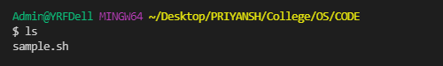

1. **mkdir:**

The mkdir command in Linux/Unix allows users to create or make new directories. Mkdir stands for "make directory." With mkdir, you can also set permissions, create multiple directories (folders) at once, and much more.

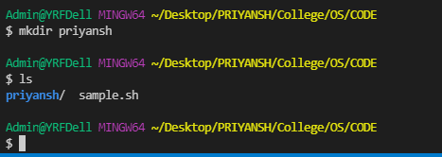

1. **cd:**

The cd ("change directory") command is used to change the current working directory in Linux and other Unix-like operating systems. 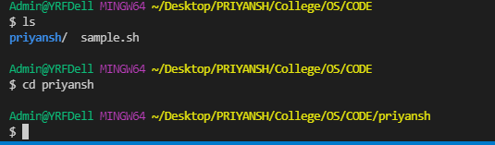

1. **rmdir:**

rmdir command is used remove empty directories from the filesystem in Linux. The rmdir command removes each and every directory specified in the command line only if these directories are empty. So if the specified directory has some directories or files in it then this cannot be removed by rmdir command.

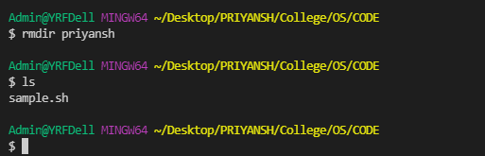

1. **cat:**

The cat (short for "concatenate") command is one of the most frequently used command in Linux/Unix like operating systems. cat command allows us to create single or multiple files, view contain of file, concatenate files and redirect output in terminal or files.

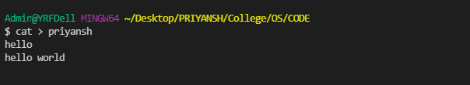

1. **rm:**

rm is the command used, in Linux terminology, to unlink file. What this means is that the directory entry for the file is removed. A side effect (and the effect that we generally expect) is that the file is deleted.

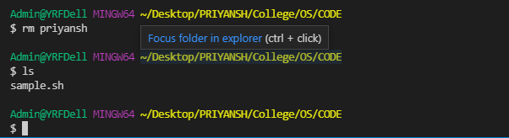

1. **mv:**

mv is used to move one or more files or directories from one place to another in file system like UNIX.

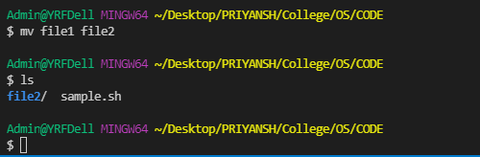

1. **cp:**

This command is used to copy files or group of files or directory. It creates an exact image of a file on a disk with different file name. cp command require at least two filenames in its argument.

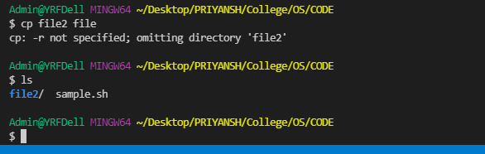

1. **head:**

The head command is a command-line utility for outputting the first part of files given toit via standard input. It writes results to standard output. By default head returns the first ten lines of each file that it is given.

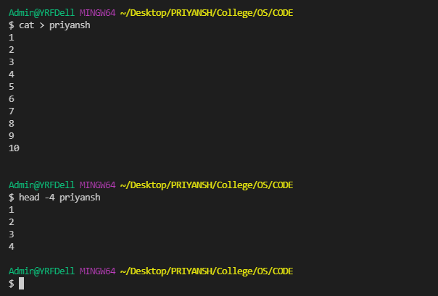

1. **tail:**

The tail command, as the name implies, print the last N number of data of the given input. By default it prints the last 10 lines of the specified files. 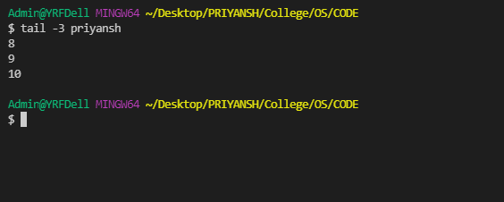

1. **sort:**

SORT command is used to sort a file, arranging the records in a particular order. By default, the sort command sorts file assuming the contents are ASCII. Using options in sort command, it can also be used to sort numerically

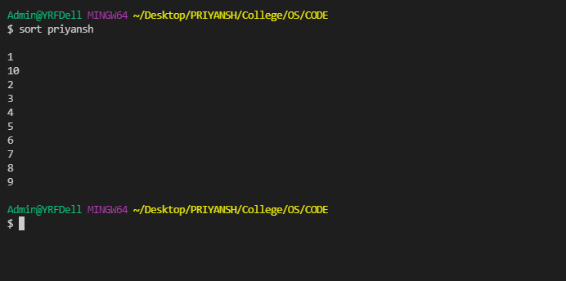

1. **wc:**

On Linux and Unix-like operating systems, the we command allows you to count the number of lines, words, characters, and bytes of each given file or standard input and print the result.

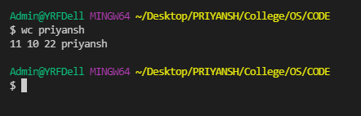

1. **chown:**

The chown command allows you to change the user and/or group ownership of a givenfile, directory, or symbolic link.

1. **chmod:**

In Unix-like operating systems, the chmod command is used to change the access mode of a file. The name is an abbreviation of change mode.

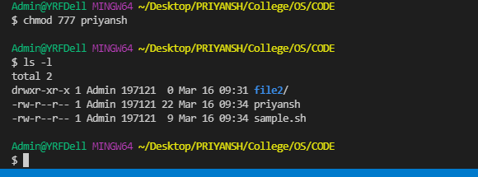

1. **chgrp:**

chgrp command in Linux is used to change the group ownership of a file or directory.

1. **umask:**

Umask, or the user file-creation mode, is a Linux command that is used to assign the default file permission sets for newly created folders and files. The term mask references the grouping of the permission bits, each of which defines how its corresponding permission is set for newly created files.

1. **ps:**

For viewing information related with the process on a system which stand for process status.

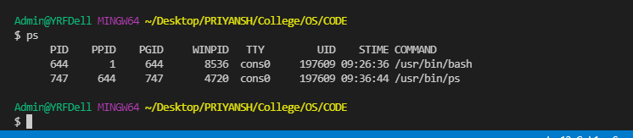

1. **pipe:**

The pipe command lets you send the output of one command to another. Piping, the as term suggests, can redirect the standard output, input, or error of one process for further processing.

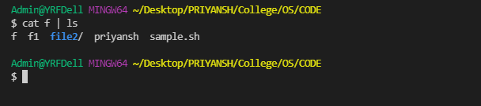

1. **Redirection operators:**

A redirection operator is a special character that can be used with a command, like a Command Prompt command or DOS command, to either redirect the input to the command or the output from the command.

